Data Technician Workbook
Week 1: Excel

Name:
Course Date:
Table of contents
Day 1: Task 1 2
Day 2: Task 1 2
Day 2: Task 2 3
Day 2: Task 3 4
Day 3: Task 1 4
Day 3: Task 2 5
Dataset: 5
Step 1: Create a Pivot Table 5
Step 2: Use the SWITCH Function 5
Submission: 6
Day 3: Task 3 6
Day 4: Task 1 7
Course Notes 9
Additional Information 10

Day 1: Task 1

Please research and complete the boxes below on common laws and regulations that must be followed when working with customers' data, and use the below bulleted list to support your answers.

- What is it
- Why is it important
- Provide a real-world example of how you can follow it
- How does it impact working with data
- What could happen if you breached it

Data Protection Act | What it is: This Act sets out the rules for how personal data is collected, stored, processed and used.  Why it's important: It protects people's personal information, prevents it from being misused, and gives individuals control over how their data is used.  Real-world example: Only collect the information you need, such as a customer's name and address for delivery, and keep it stored securely.  Impact on data work: You must record why you collect data, keep it accurate, and delete it when it is no longer needed.  Breach consequences: Fines can be up to £17.5 million, and organisations can also lose customer trust.  Source: Data Protection Act 2018 GOV (
GDPR | What: UK laws on how people’s data can be collected, preserved and explored.  Why: It's important as its Keeps people's personal information safe and lets them decide how it's used.  Example: Taking only details you need, and getting consent/ approval before marketing emails or data  Impact: data must be kept accurate, secure, and all breaches must be report to the ICO within 72 hours.  Breach: Fines up to £17.5 million or 4% of turnover.  Source: ICO UK GDPR guidance
Freedom of Information Act | What: Lets the public request information held by public authorities.  Why: Keeps public bodies open and accountable to the people they serve.  Example: Responding to a request for council spending records within 20 working days.  Impact: Authorities must share held data unless a valid exemption applies.  Breach: ICO can investigate complaints and order disclosure of the information.  Source: ICO – Freedom of Information Act ICO

Day 2: Task 1

Please research and complete the following tasks within the retail-sales_dataset.xlsx document, and paste a print screen into the provided boxes below:

- In the sheet ‘retail_sales_dataset’, add all available data between columns A – H into a ‘table’ using Ctrl+T. Then name the table.
- Using the ‘filter’ function, filter ‘Age’ from ‘largest to smallest’
- Using the ‘SUM’ function, show me the commission total in cell ‘P10’
- Using the ‘AVERAGE’ function, show me the average commission in cell ‘P11’

Print screen 1 | 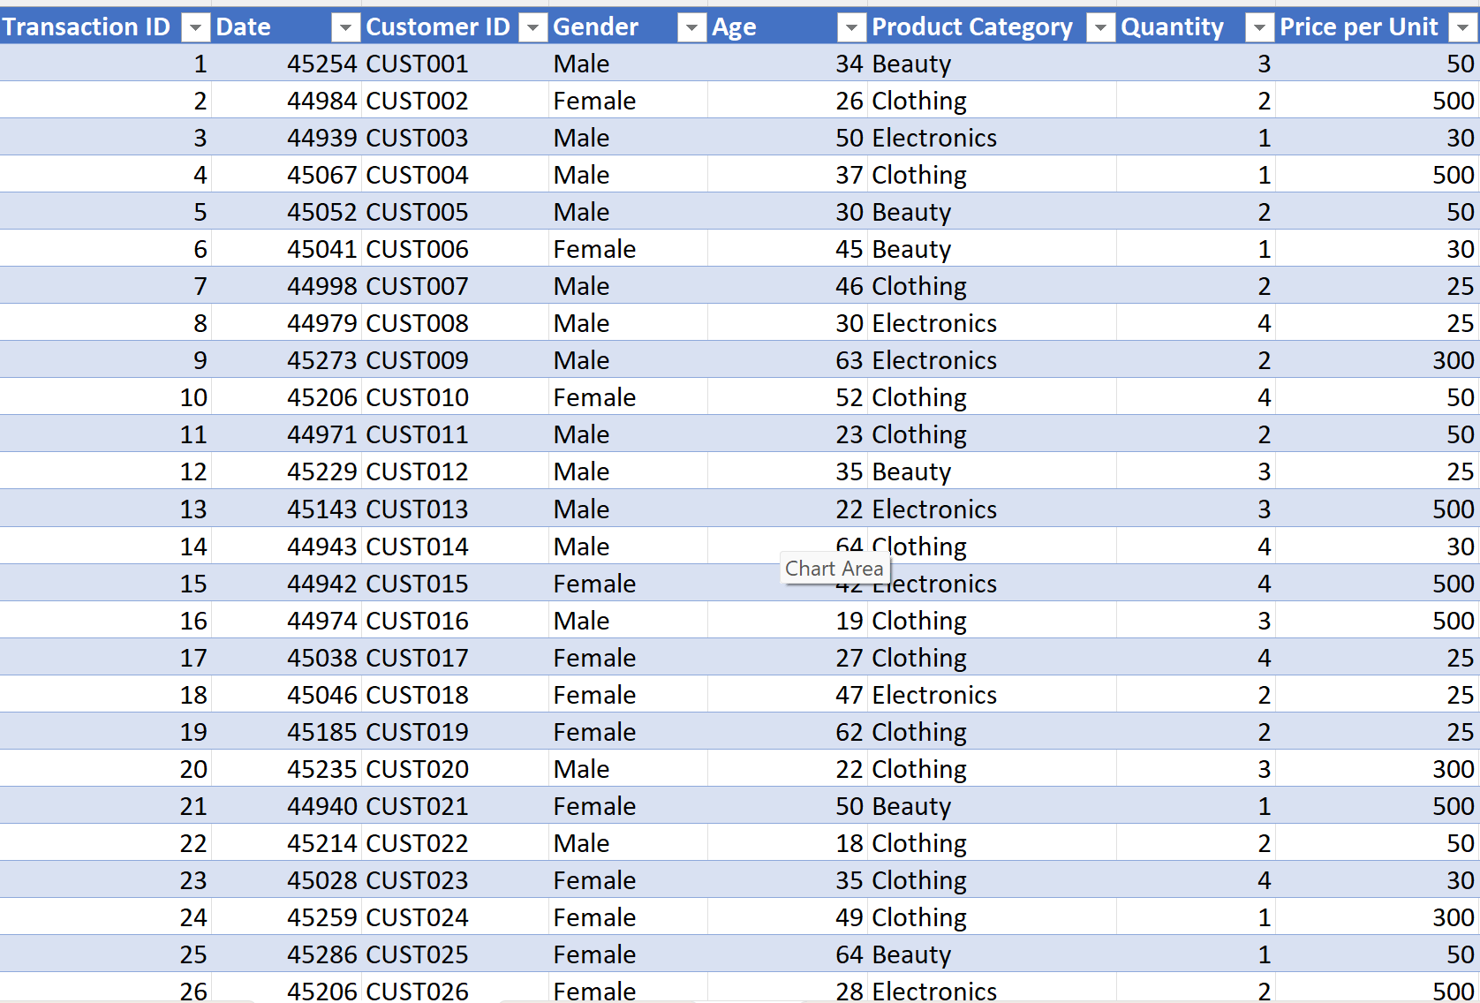
Print screen 2 | 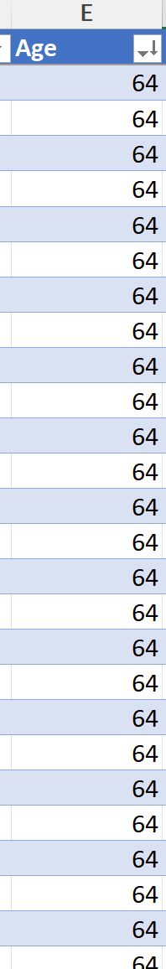
Print screen 3 | 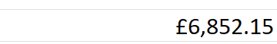
Print screen 4 | 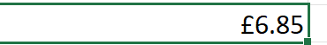

Day 2: Task 2

Please research and complete the following tasks within the document, and paste print screens into the provided box below:

Use the Student grades table provided by the tutor,

Convert the table to an Excel table. (Ctrl +T)

Student name | English | Mathematics | Science | Average | Highest score
Carol | 75 | 85 | 85
Khan | 85 | 75 | 80
Harry | 80 | 70 | 80
Sarah | 80 | 70 | 80
John | 65 | 80 | 70
Linda | 90 | 50 | 70
Edward | 55 | 80 | 60
Mary | 55 | 70 | 65
Thomas | 55 | 30 | 65

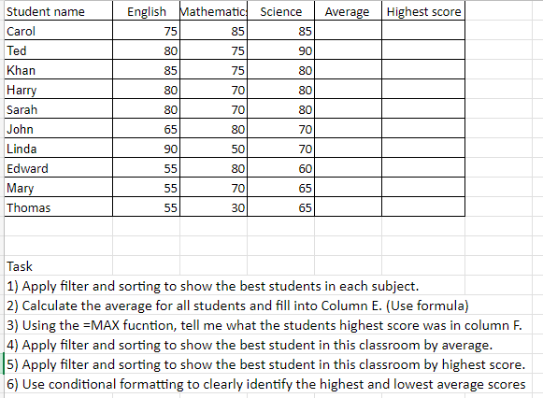

Print screen 1 | 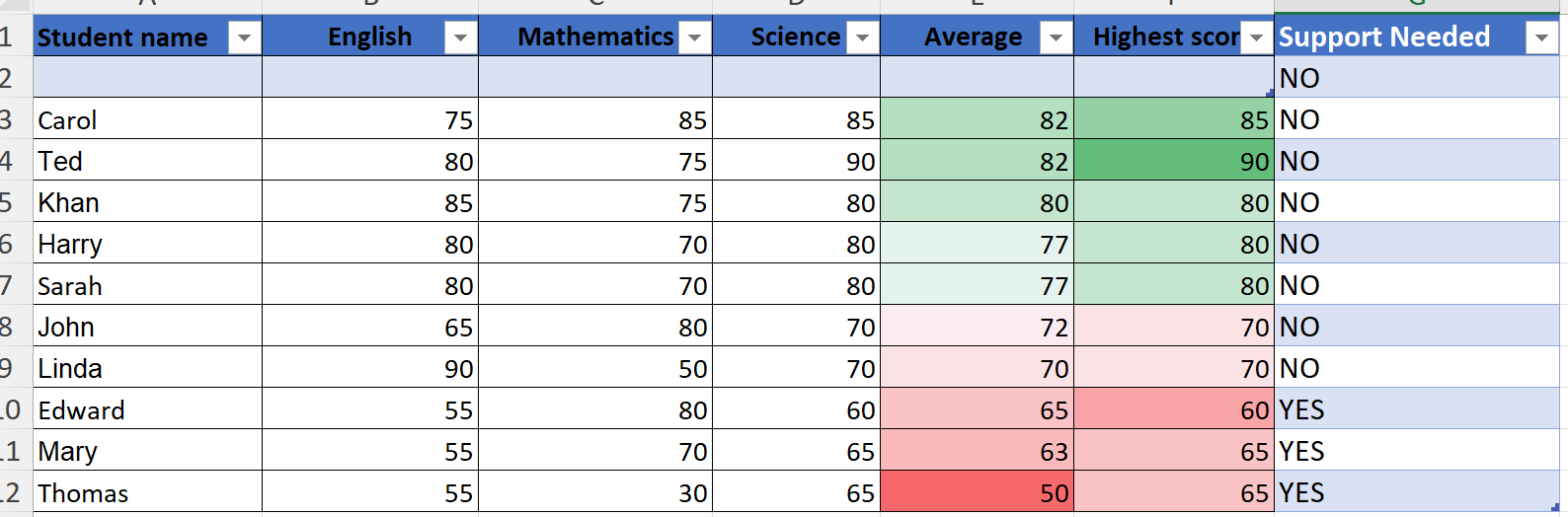

Day 2: Task 3

Using the skills developed today, have some fun with the data set you have imported. Paste your work below and enjoy!

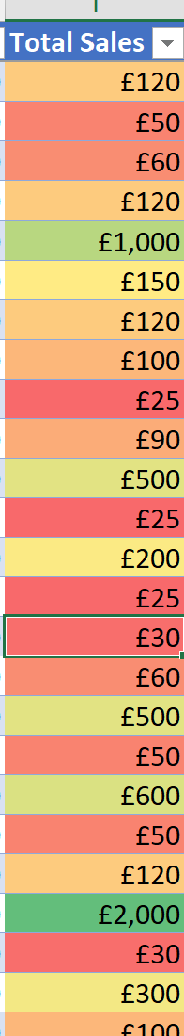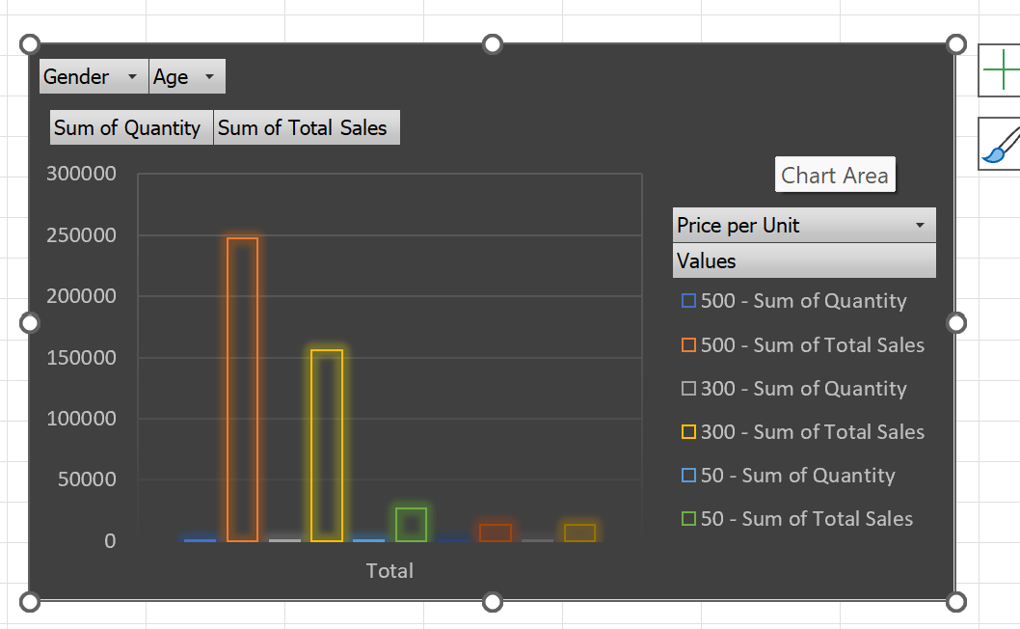
Print screen 1 | Teaches: visual outlier detection without a chart  Teaches: how single-page Pivot reporting gets built from the pieces above

Day 3: Task 1

Dataset: Day_3_Task_1_Bike_Sales_Pivot_Lab.xlsx. and,
Lab instructions: Lab pivot table use for task 1 instructions

Make a copy of the dataset. Use the copy.

Convert to Excel Table (Ctrl +T)

Follow the lab instructions. Do not worry if you do not complete the lab; just working with data and playing with the pivot table will be a good experience.

Note:
Under refine the pivot table:
To mask 0's.
Click the pivot table
Click the Pivot Table Analyse tab on the menu bar.
Options > options > layout and format> In the field for empty cells, select the checkbox and enter 0 (zero). Ok.

And for the reflection questions, please do them in your workbook, not in the lab.

Please paste your final pivot table below and complete the reflection questions:

Print screen 1 | 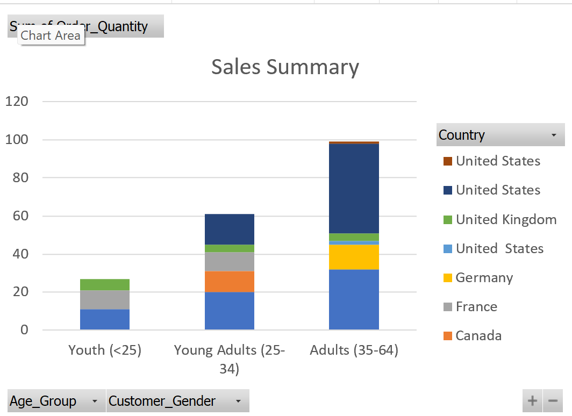
In which markets does Germany have customers? | Adults(35-64)
What country has sales in all markets? | Australia and United Kingdom
What are the most profitable markets by country, age group, and gender? | 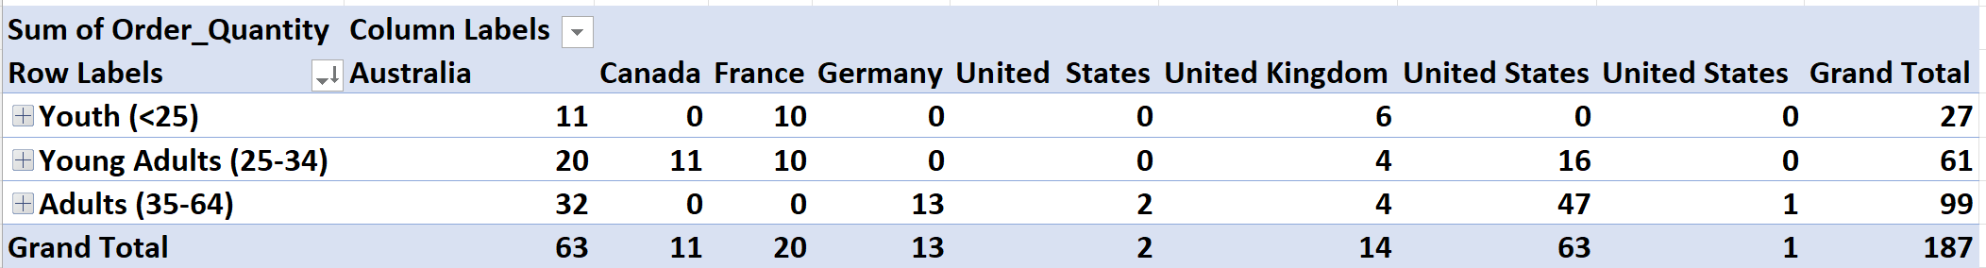
Any other findings?

Day 3: Task 2

The dataset below tracks the sales performance of different products in various counties in England. Please paste the dataset into a blank Excel workbook. Your task is to:
- Create a Pivot Table to summarise the data by county and product.
- Use the SWITCH function to categorise products based on their sales volume.
See instructions below.

The dataset can be found in the last workbook you used.

County | Product | Sales Volume
Yorkshire | Laptops | 500
Yorkshire | Smartphones | 200
Cornwall | Laptops | 700
Cornwall | Printers | 400
Lancashire | Smartphones | 150
Lancashire | Laptops | 600
Essex | Printers | 800
Essex | Smartphones | 300
Durham | Laptops | 250
Durham | Printers | 300
Greater Manchester | Smartphones | 600
Greater Manchester | Laptops | 400

Dataset:

Step 1: Create a Pivot Table
- Select the dataset (columns A to C).
- Insert a Pivot Table to summarise the data by County in the rows and Products in the columns. Use Sales Volume as the value to be summarised.

Step 2: Use the SWITCH Function
In a new column next to your data, use the SWITCH function to categorise products based on Sales Volume as follows:
For sales greater than 600: "High"
For sales between 300 and 600: "Medium"
For sales less than 300: "Low"

SWITCH Function Example:
=SWITCH(TRUE, C2 > 600, "High", C2 >= 300, "Medium", "Low")

- Apply this formula to each row, and check if the products are categorised correctly.
- In ‘Sales Volume’, you need to remove the space after each amount – hidden spaces
- Confirm the data type is numerical

Submission:
- A completed Pivot Table summarising sales by county and product.
- A new column in the dataset categorising products by sales volume using the SWITCH function.
  - Please paste your completed work below

Print screen 1 | 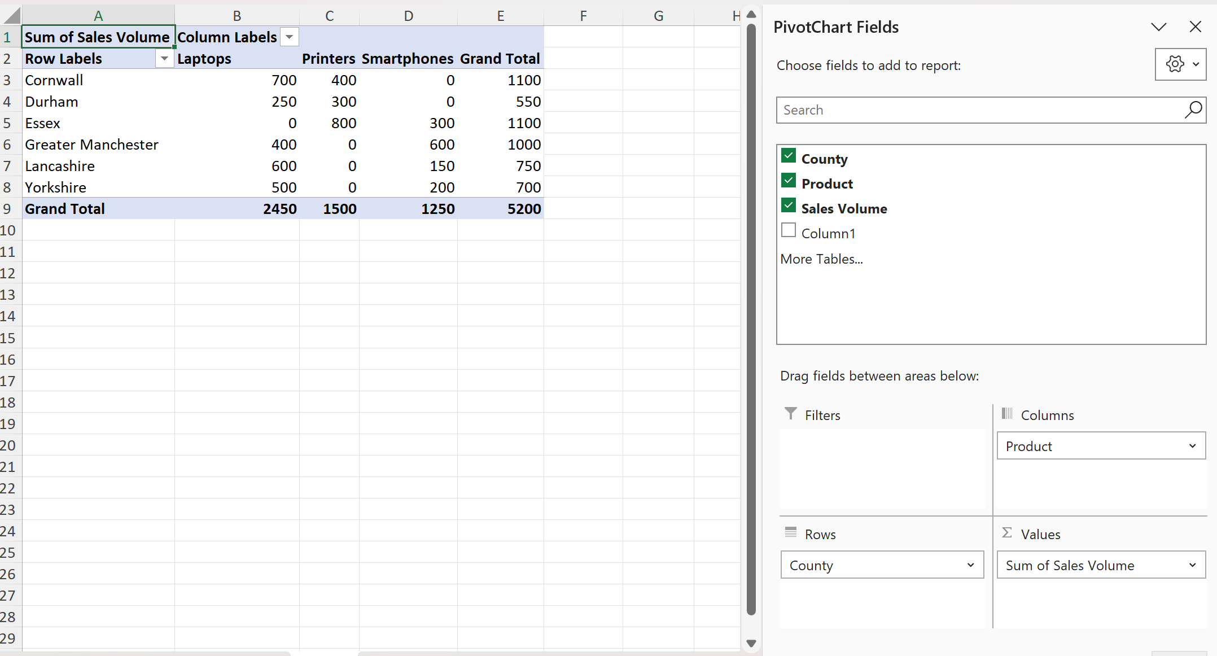  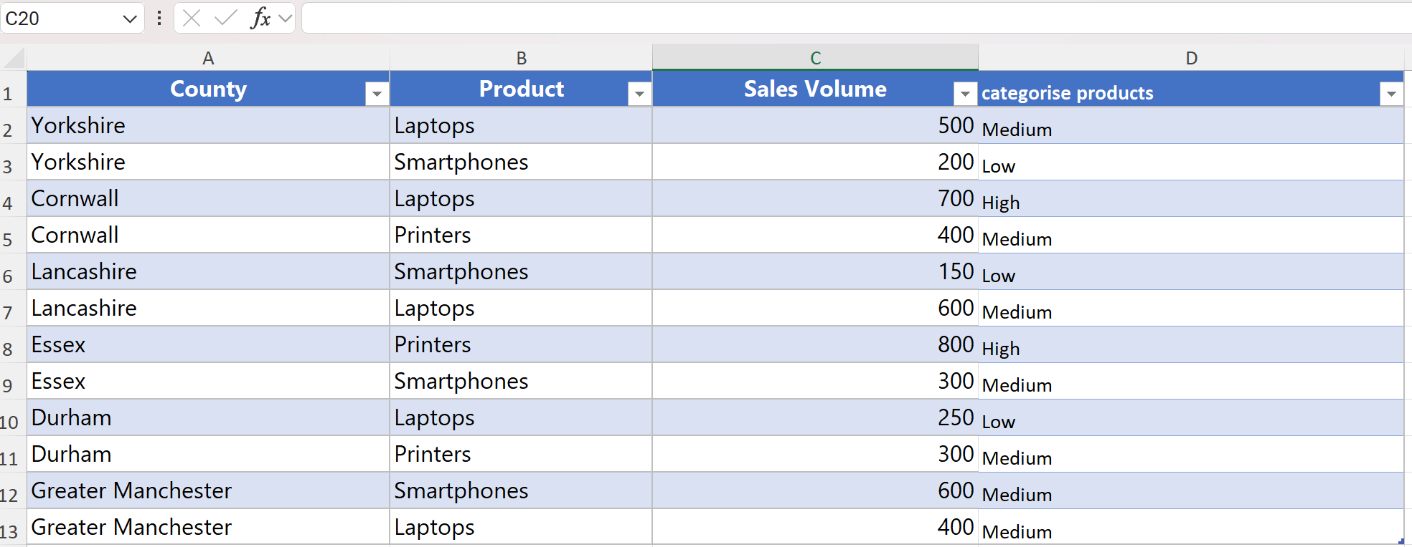

Day 3: Task 3

Please download the dataset ‘Day_3_Task_3_Bike_Sales_Visualisations_Lab.xlsx’.
Also, download the lab instructions.

Pivot tables are already created; you will need to create the pivot charts.

Follow the lab instructions.

Do not worry if you do not complete the lab; just working with data and playing with the charts will be a good experience.

Please paste your results below:

Print screen 1 | 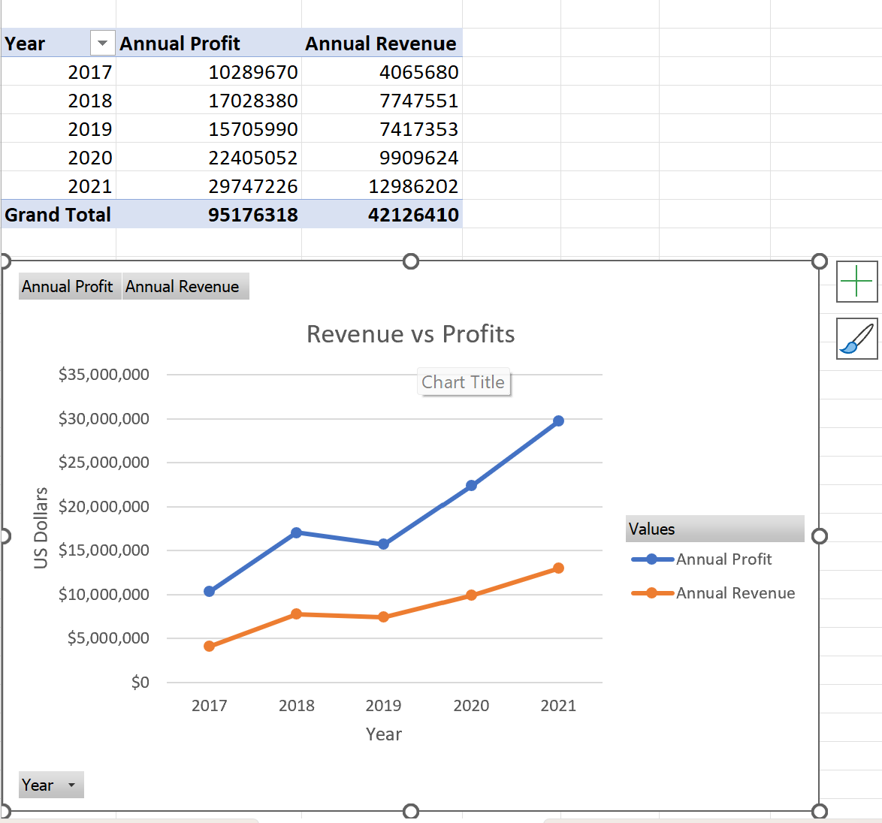  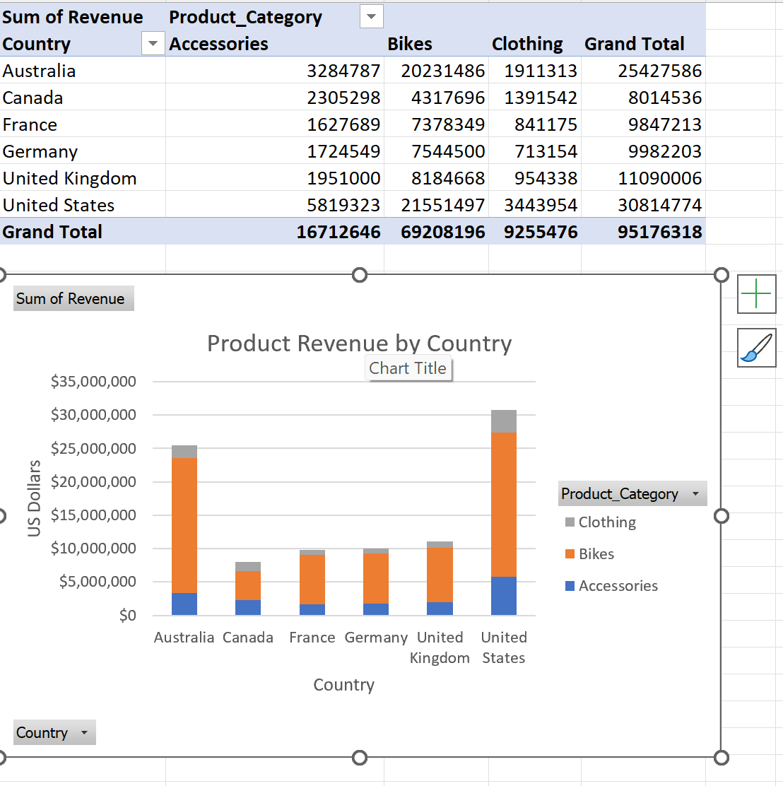  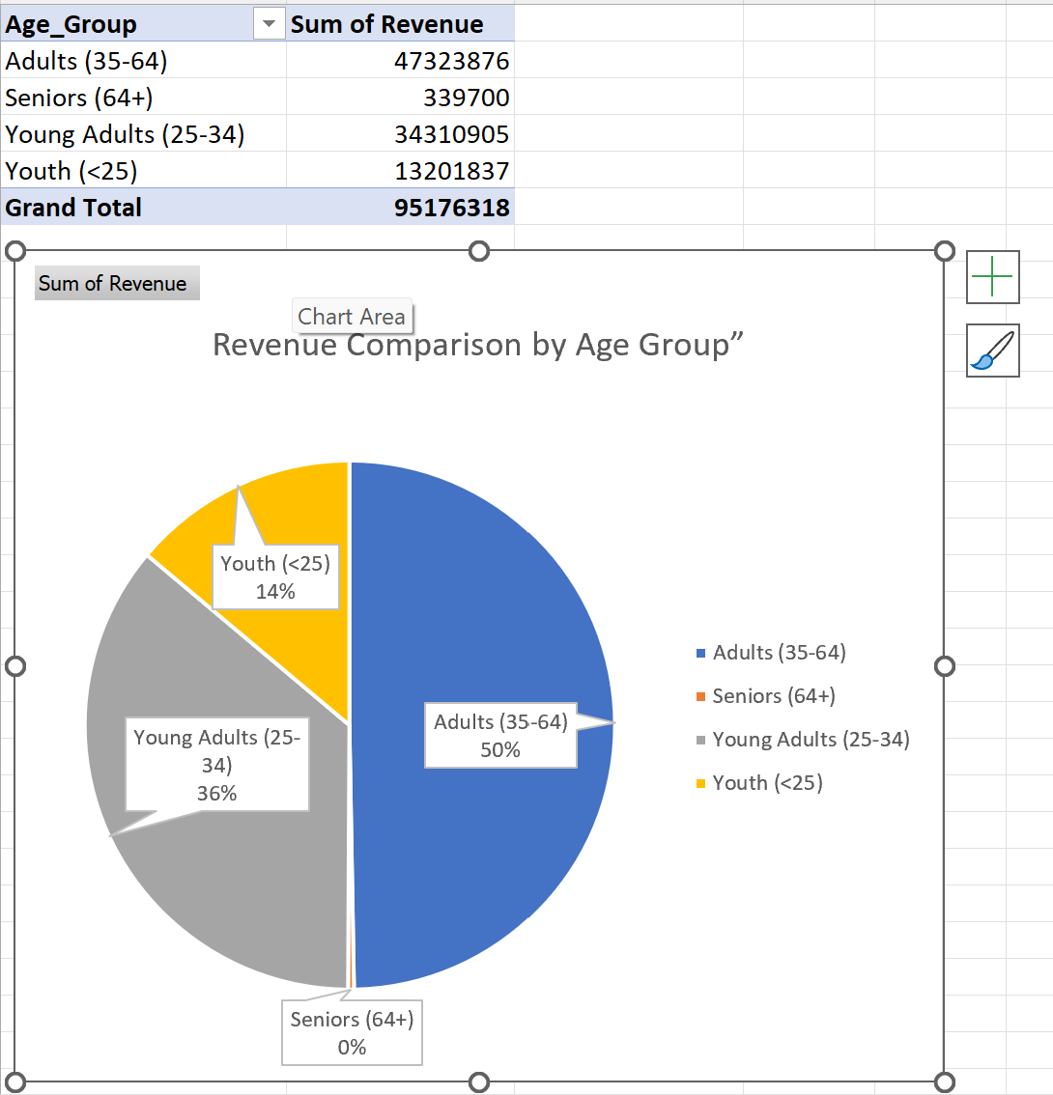

Day 4: Task 1

You have been asked to deliver your analysis findings to the board of directors. Within your analysis, you have identified that customers are leaving your company at the 12-month point, which is typically when they receive their renewal price.

Choose a business or organisation to focus your findings on.

Conduct research and complete the following questions:

As in all work situations, you can use AI Gen tools for research: it needs to be in British English, check spelling, grammar and maths; and written in your voice, not copied directly from the tool.

How would you prepare for the delivery? | Before showing my results, I'd double check my work to make sure it's right and clearly proving that a lot of Vodafone customers cancel once they get their 12-month renewal price. Then I'd make a short presentation with charts and graphs, so it's easy to understand how many customers are leaving and how much money Vodafone is losing because of it.  I'd also practise going through the presentation a few times, so I feel confident and can answer any questions without getting stuck. I wouldn't just point out the problem though. I'd also suggest some real fixes, like giving loyalty rewards to customers who stay with Vodafone, offering personal discounts based on their contract history.
What tools would you use for the delivery? | I'd use PowerPoint to put together a professional looking presentation, and Excel to look through the data and turn it into charts that are easy to understand.  If I wanted something more advanced, I'd use Power BI to build interactive dashboards, so people could explore the data themselves if needed.  For a remote meeting, I'd use Microsoft Teams to deliver the presentation, and OneNote to keep my notes and preparation organised in one place.  I'd also use Copilot or other AI tools to help me draft some of the content, summarise my findings, and check my grammar before presenting.  All of these tools together help me communicate clearly and make complicated information much easier for others to understand.
What is prospecting, and why would you complete this before your delivery? | means doing your research on who you're presenting to before you deliver it. So, things like finding out who'll be in the room (or meeting), what they already know about the topic, what they care about, and what kind of questions they might ask.  Sources:  - MindTools  - LinkedIn Learning
Tell me the best practices for public speaking and providing updates to senior leaders | When presenting, I'd make sure to speak clearly and sound confident, keep eye contact with the audience, and use good body language so I come across as engaged. I wouldn't just read off the slides, I'd keep my points short and to the point, and pause after saying something important so it has time to sink in. I'd also make sure I'm ready to answer any questions that come up.  When updating senior leaders specifically:  I'd focus mainly on how the issue affects the business, and back up what I'm saying with real data and evidence rather than just opinions. I'd keep it short and straight to the point, while still covering the risks, opportunities, and what I'd recommend doing about it. I'd also clearly explain why my recommendations would benefit the business.  Basically, senior leaders don't want loads of detail, they'd rather see a simple dashboard, a quick summary, and clear next steps they can act on.  Sources:  - Toastmasters International  - TED Talks  - MindTools
What will you show the board in your delivery? | I'd show the board a line graph highlighting how cancellations rise once customers reach their 12-month renewal point, along with a dashboard tracking retention rates by month. I'd also include revenue figures to show the actual financial impact of customers leaving, plus feedback data on the main reasons behind it, like price increases or competitors offering better deals. Alongside this, I'd present some recommended actions to help improve retention, and forecasts showing the potential improvements if these changes are made. Altogether, this would give the board clear, evidence-based insights to support their decision making.  Sources:  - Microsoft Learn Power BI:  - Ofcom:
How will you articulate the changes that are needed? | To explain the changes clearly, I'd start with the "why". I'd show the business case for change first, being clear about why it's needed and why now, so nobody's left guessing. I'd then walk through what the changes mean day to day, like how the loyalty rewards or personalised discounts would work in practice, and what results Vodafone could expect from them.  I'd also leave room for questions, because stakeholders respond better when they feel involved and heard, not just told what's happening. Finally, I'd explain what success would look like, so Vodafone's leaders know how we'd measure whether the changes worked.  Sources:  LSA Global  Change Management Insight
Provide a list of online resources and videos that will support your preparation for public speaking | list of resources to help with public speaking prep, and they are all free to access as well.  Free Courses  - Coursera – Introduction to Public Speaking (University of Washington): covers speech organisation, delivery, and beating nerves  - edX – Public Speaking for Beginners (RIT): teaches how to prepare and structure a speech  TED Talks  Provides examples of engaging and effective presentations.  How to Speak So That People Want to Listen  Julian Treasure (TED Talk)
Evaluate tools that provide visualisation.  Tell me what they are.  Tell me what you would choose when delivering your presentation and why | Microsoft Excel - Good for turning raw numbers into simple charts like line graphs, bar charts, and pie charts. It's easy to use and most people are already familiar with it. Excel is by far the most popular data management, reporting and daily analysis tool, though the charts can look a bit basic and aren't interactive  Sources: Why is Microsoft Excel  PowerPoint – not really for analysing data, but good for pulling finished charts together into a clean, simple presentation that's easy for an audience to follow.  Google Sheets – like Excel, decent for basic charts, useful mainly if I needed to collaborate with someone else on the data.  Sources:  - CCS Learning Academy, Power BI vs Excel: Top 10 Differences Explained:  - TenHats, Power BI vs. Excel for Data Visualization:  - Microsoft, Data Visualization with Excel and Power BI:

Course Notes

It is recommended to take notes from the course, use the space below to do so.
We learned how to protect a spreadsheet by adding a password to it, so only certain people can open or edit it.
Rearranging data
We learned about transpose, which basically flips your data around, turning rows into columns (or the other way round), without having to retype everything.
Doing basic maths on a column
We practised working out totals, minimums, maximums, and averages for a range of cells, like =SUM, =MIN, =MAX, and =AVERAGE. These just add up, or find the smallest, biggest, or average value in a set of numbers.
Doing maths based on a condition
We learned how to total or average numbers, but only for a certain category, like adding up all the sales just for "Beauty" products using =SUMIF, or finding the average sales for just one category using =AVERAGEIF. We also used =SUMIFS, which lets you filter by more than one condition at once, like Beauty products bought by females only.
Finding unique values
We used =UNIQUE to pull out a list of all the different categories in a column, without any repeats.
Sorting things into groups
We practised using =IF, =IFS, and =SWITCH to automatically label things based on a value, like sorting people into "Young Adult," "Adult," or "Senior" depending on their age, or labelling something as "High," "Medium," or "Low" depending on a number.
Looking up information
We used =VLOOKUP to pull matching information from another sheet, based on something like an ID number.
Counting cells
We learned the difference between =COUNT (counts numbers only), =COUNTA (counts anything that isn't empty), and =COUNTBLANK (counts empty cells).

Additional Information

We have included a range of additional links to further resources and information that you may find useful, these can be found within your revision guide.

END OF WORKBOOK

Please check through your work thoroughly before submitting and update the table of contents if required.

Please send your completed work booklet to your trainer.

